**OBRÁZKOVÉ SUDOKU**

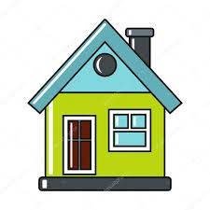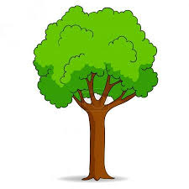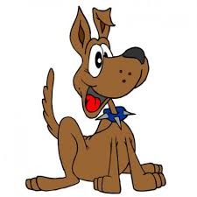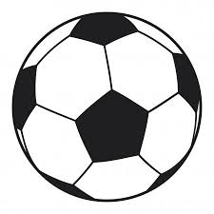

|  |  |  |  |  |  |  |  |  |
| --- | --- | --- | --- | --- | --- | --- | --- | --- |
| C:\Users\Marcela\Pictures\hlavolamy\dům.jpg | C:\Users\Marcela\Pictures\hlavolamy\strom.jpg | C:\Users\Marcela\Pictures\hlavolamy\slunce.png | C:\Users\Marcela\Pictures\hlavolamy\ptáček.jpg | C:\Users\Marcela\Pictures\hlavolamy\pes.jpg | C:\Users\Marcela\Pictures\hlavolamy\index.jpg | C:\Users\Marcela\Pictures\hlavolamy\balón.jpg | C:\Users\Marcela\Pictures\hlavolamy\jahoda.jpg | C:\Users\Marcela\Pictures\hlavolamy\kytička.png |
|  |  | C:\Users\Marcela\Pictures\hlavolamy\index.jpg | C:\Users\Marcela\Pictures\hlavolamy\balón.jpg |  | C:\Users\Marcela\Pictures\hlavolamy\kytička.png | C:\Users\Marcela\Pictures\hlavolamy\dům.jpg |  | C:\Users\Marcela\Pictures\hlavolamy\slunce.png |
|  | C:\Users\Marcela\Pictures\hlavolamy\jahoda.jpg | C:\Users\Marcela\Pictures\hlavolamy\kytička.png |  | C:\Users\Marcela\Pictures\hlavolamy\strom.jpg | C:\Users\Marcela\Pictures\hlavolamy\slunce.png | C:\Users\Marcela\Pictures\hlavolamy\ptáček.jpg | C:\Users\Marcela\Pictures\hlavolamy\pes.jpg |  |
| C:\Users\Marcela\Pictures\hlavolamy\strom.jpg | C:\Users\Marcela\Pictures\hlavolamy\slunce.png | C:\Users\Marcela\Pictures\hlavolamy\dům.jpg | C:\Users\Marcela\Pictures\hlavolamy\pes.jpg |  | C:\Users\Marcela\Pictures\hlavolamy\ptáček.jpg |  | C:\Users\Marcela\Pictures\hlavolamy\kytička.png | C:\Users\Marcela\Pictures\hlavolamy\balón.jpg |
| C:\Users\Marcela\Pictures\hlavolamy\pes.jpg |  | C:\Users\Marcela\Pictures\hlavolamy\ptáček.jpg |  | C:\Users\Marcela\Pictures\hlavolamy\kytička.png | C:\Users\Marcela\Pictures\hlavolamy\balón.jpg | C:\Users\Marcela\Pictures\hlavolamy\strom.jpg |  | C:\Users\Marcela\Pictures\hlavolamy\dům.jpg |
| C:\Users\Marcela\Pictures\hlavolamy\jahoda.jpg | C:\Users\Marcela\Pictures\hlavolamy\kytička.png | C:\Users\Marcela\Pictures\hlavolamy\balón.jpg | C:\Users\Marcela\Pictures\hlavolamy\strom.jpg |  |  | C:\Users\Marcela\Pictures\hlavolamy\pes.jpg | C:\Users\Marcela\Pictures\hlavolamy\index.jpg |  |
| C:\Users\Marcela\Pictures\hlavolamy\slunce.png | C:\Users\Marcela\Pictures\hlavolamy\dům.jpg | C:\Users\Marcela\Pictures\hlavolamy\strom.jpg |  | C:\Users\Marcela\Pictures\hlavolamy\ptáček.jpg | C:\Users\Marcela\Pictures\hlavolamy\pes.jpg |  | C:\Users\Marcela\Pictures\hlavolamy\balón.jpg | C:\Users\Marcela\Pictures\hlavolamy\jahoda.jpg |
|  |  | C:\Users\Marcela\Pictures\hlavolamy\pes.jpg | C:\Users\Marcela\Pictures\hlavolamy\kytička.png |  | C:\Users\Marcela\Pictures\hlavolamy\jahoda.jpg | C:\Users\Marcela\Pictures\hlavolamy\slunce.png |  | C:\Users\Marcela\Pictures\hlavolamy\strom.jpg |
|  | C:\Users\Marcela\Pictures\hlavolamy\balón.jpg | C:\Users\Marcela\Pictures\hlavolamy\jahoda.jpg |  |  | C:\Users\Marcela\Pictures\hlavolamy\strom.jpg | C:\Users\Marcela\Pictures\hlavolamy\index.jpg | C:\Users\Marcela\Pictures\hlavolamy\ptáček.jpg |  |